**Training case study**

Login page with roles

Admin and user

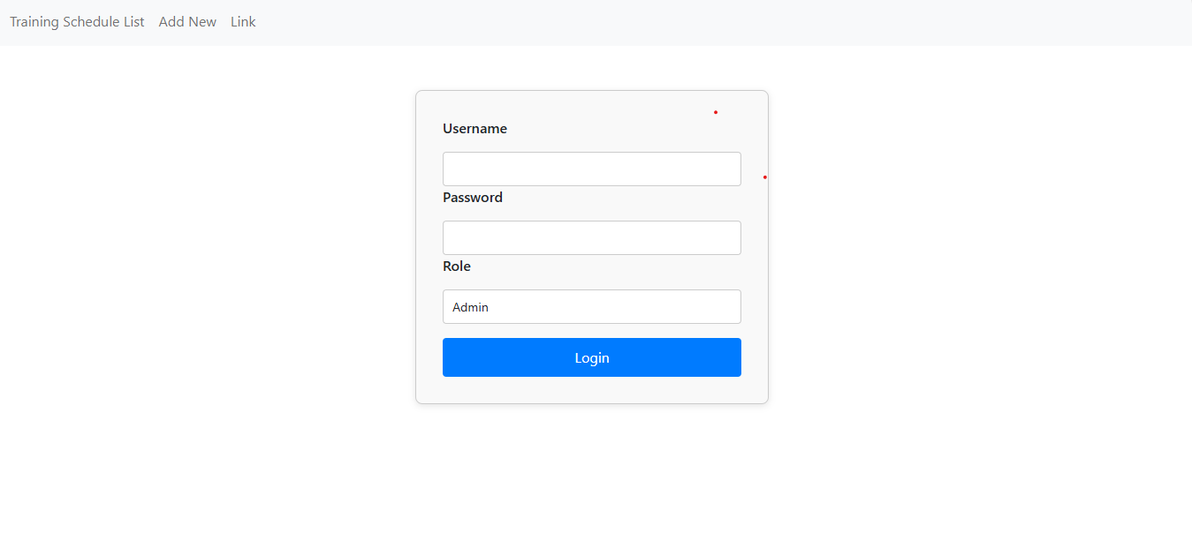

**Training schedule list**  
below screenshot will list all the training list that are scheduled which connected with api to fetch the data

Btn add new to add new training in the list

Btn edit to edit the details of the training

Brn delete to delete it from the list

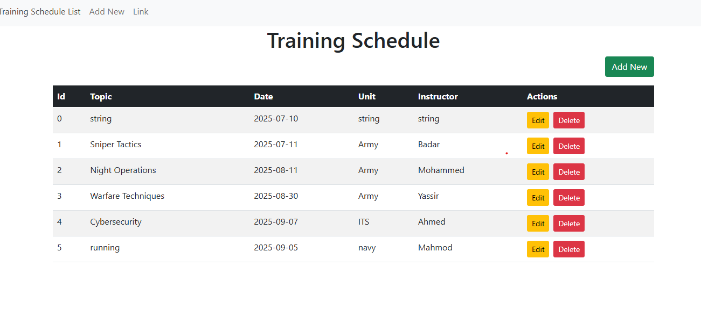

**Add new Training**

after adding new training, it will be added in the list and the id will be auto generated

all fields of the form are required

